Name: John Francis   
Date: 2/26/2023  
Professor: Dr. Gray

First Hop Redundancy Protocol (FHRP)

**Write a paragraph** (minimum five college-level sentences) below that summarizes what was accomplished in this activity, what you learned by performing it and just as important, how you feel it will benefit you in your academic and professional career. (6 points)

In this exercise we issued command to configure group 10 with a higher that default preference. And configured pre-empt so that the device will force a failback in the event that it recovers after a failure.

We configured the other router to be the standby router. We configures HSRP tracking such that if an interface goes down on the switch the priority will fall to below the standby devices priority. Then we bind the tracking object to the HSRP group and decrement the priotiry of this group by 15. This will drop the priority to 95, which is 5 below the priority of the original router. Learning this process will help me to under stand what our lesson teaches as well as helping me to understand what will happen in the event of a failover in my professional career.

Copy and paste the required screenshots from the **FHRP Configuration and Verification**activity, **Exercises 1 and 2**, and answer the questions below.

**Exercise 1 – Task 1, Step 3:** Paste a screenshot after executing the show standby vlan 1 command on NYCORE1. Make sure your screenshot contains the required time/date stamp! (6 points)

**Exercise 1 – Task 1, Step 5:** Paste a screenshot after executing the show standby vlan 1 command on NYCORE1. Make sure your screenshot contains the required time/date stamp! (6 points)

**Exercise 1 – Task 2, Step 4:** Paste two screenshots showing the output of NYCORE1 and NYCORE2 after executing the commands in step 3. Make sure your screenshot contains the required time/date stamp!

(7 points)

**Exercise 1 – Task 2, Step 9:** Paste a screenshot showing the Interface FastEthernet1/0/1 changing state to up and the Standby change after approximately 15 seconds. Make sure your screenshot contains the required time/date stamp! (7 points)

**Exercise 2 – Task 1, Step 1:** Paste a screenshot of the output from NYEDGE1 after executing the second exit command in step 1. Make sure your screenshot contains the required time/date stamp! (6 points)

**Exercise 2 – Task 2, Step 4:** Paste two screenshots showing the output of NYEDGE1 and NYEDGE2 after executing the command show vrrp brief on both devices. Make sure your screenshots contain the required time/date stamp! (7 points)

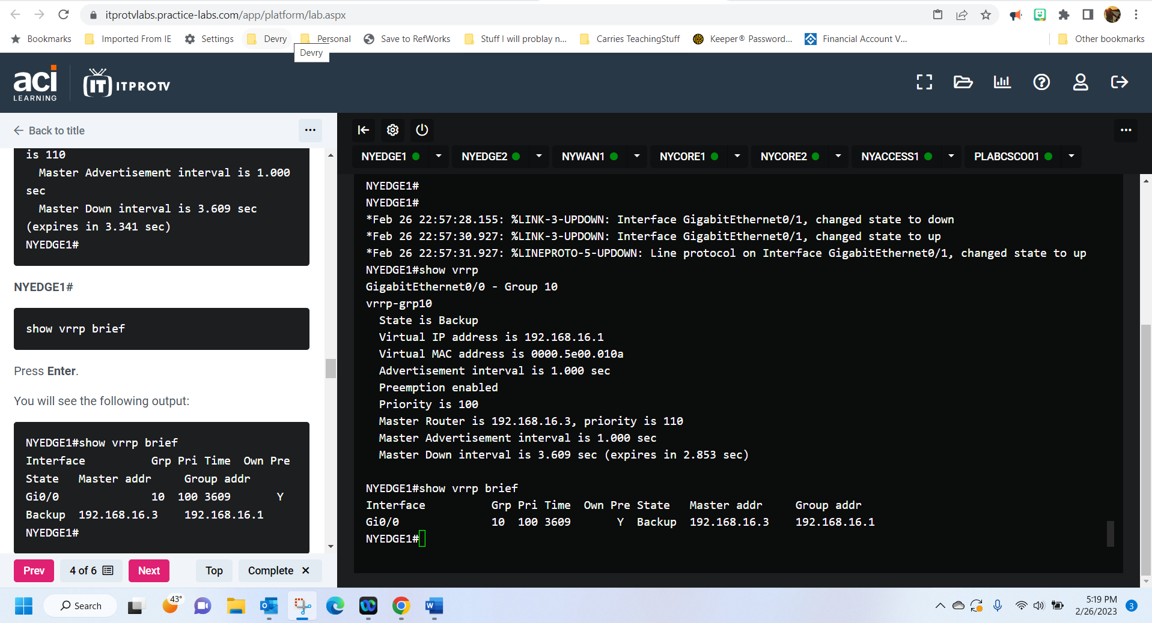

**Congratulations! You are done with Module 1 graded practice activities!**